**Kernel in Operating System**

The **kernel** is the **core part of an operating system (OS)**.  
It acts as a **bridge between hardware and software** — meaning it lets your applications talk to your computer’s CPU, memory, and devices.

Think of it like this:

* **Applications** (like browsers, games, editors) → ask the kernel for resources.
* **Hardware** (CPU, RAM, disk, devices) → is controlled and managed by the kernel.
* The **kernel** sits in the middle, managing everything safely and efficiently

**🔹 System Call (Syscall)**

A **system call** is the way for a **user program (running in user mode)** to request a service from the **kernel (running in kernel mode)**. Can be treated as a software interrupt.

Since **user programs can’t directly access hardware** (for safety and security), they use system calls as a **gateway**.

**🔹 Examples of Services Requested via System Calls**

1. **File Management**
   * Open, read, write, close files.
   * Example: open(), read(), write().
2. **Process Management**
   * Create or terminate processes.
   * Example: fork(), exec(), exit().
3. **Memory Management**
   * Request memory allocation.
   * Example: mmap(), brk().
4. **Device Management**
   * Access hardware devices via drivers.
   * Example: ioctl() for device control.
5. **Communication**
   * Send/receive data between processes.
   * Example: pipe(), socket().

**🔹 How It Works (Step by Step)**

1. **Program needs a resource** → e.g., read a file.
2. **Makes a system call** → e.g., read(fd, buffer, size).
3. **Switch to kernel mode** → CPU switches from **user mode → kernel mode** (via a software interrupt/trap).
4. **Kernel executes the request** → communicates with hardware, retrieves data.
5. **Return to user mode** → result is sent back to the program.

# 🔹 What is an Operating System (OS)?

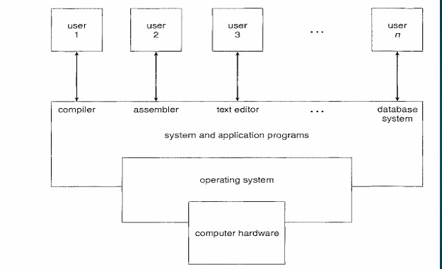

An **Operating System** is **system software** that acts as an **interface between the user and the computer hardware**.

It manages:

* Hardware resources (CPU, memory, I/O devices)
* Software execution (programs, processes)
* User interaction (UI, commands)

👉 In short:  
**OS = resource manager + control program + user interface.**

# 🔹 Functions of OS

1. **Process Management** – scheduling, multitasking.
2. **Memory Management** – allocation, protection, virtual memory.
3. **File System Management** – storing, retrieving, organizing data.
4. **Device Management** – handling I/O devices via drivers.
5. **Security & Protection** – access control, authentication.
6. **User Interface** – CLI (command line) or GUI (graphical).

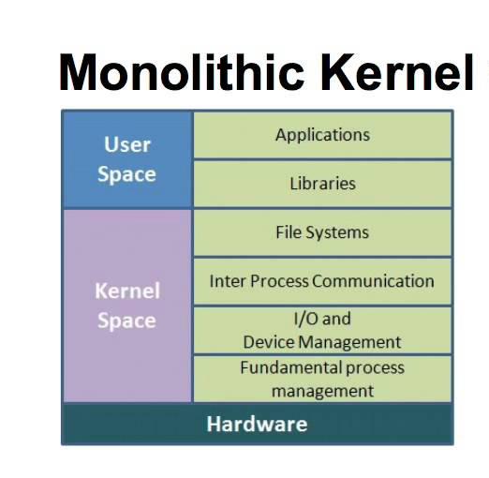

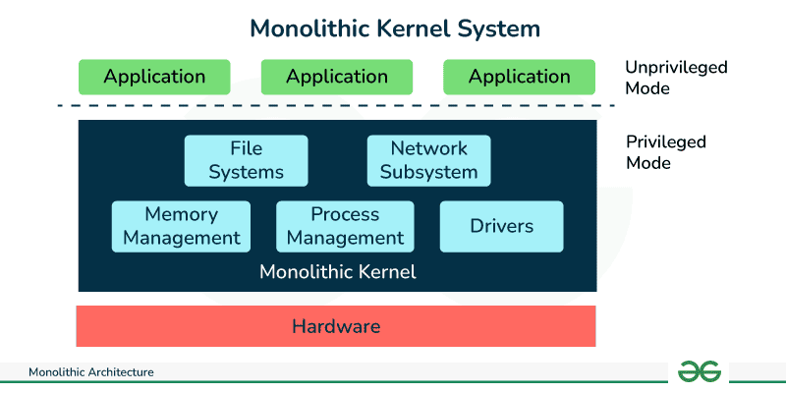

## 🔹 What is a Monolithic Operating System?

A **monolithic OS** is the **simplest and oldest** operating system structure.  
Here, the entire operating system runs as **a single large process** in **kernel mode**.

* All OS services (file system, memory management, process scheduling, device drivers, etc.) are inside **one big kernel**.
* Since everything is together, **any procedure can call any other procedure directly**.

## 🔹 Characteristics of Monolithic Systems

1. **Single Large Kernel** – All core services are compiled into one executable.
2. **Procedure Calls** – OS functions interact using normal function/procedure calls, no extra overhead.
3. **Tightly Coupled** – Components are not isolated; they are interdependent.
4. **Fast Execution** – Since everything is in one memory space, no context switching between modules.
5. **Difficult to Maintain** – Changing one part may break others, debugging is harder.

## 🔹 Structure (Layers inside Kernel)

* **Hardware**
* **System Call Interface** (entry point for user programs → kernel)
* **Kernel Services** (file system, device drivers, memory management, process scheduling, etc.)
* **User Applications**

Everything except user applications is inside one **monolithic kernel**.

## 🔹 Advantages

✅ **Efficient & Fast** – direct procedure calls, less overhead  
✅ **Simple Design** – conceptually easy to implement (good for early systems)  
✅ **Good Performance** – low communication cost between OS components

## 🔹 Disadvantages

❌ **Poor Modularity** – hard to modify or extend  
❌ **Large & Complex** – kernel grows huge with more services  
❌ **Less Secure** – if one service crashes (e.g., driver), whole system may crash  
❌ **Difficult Debugging** – small bug can break the entire OS

## 🔹 Examples

* **MS-DOS**
* **Unix (original versions)**
* **Linux (though modularized, still considered monolithic)**

👉 So in short:  
A **monolithic OS** = "one big program running in kernel mode that does everything." 🚀

## 

## 🔹 What is a Layered Operating System?

In a **layered OS**, the operating system is divided into **different layers (levels)**, each built on top of the lower one.

* Each layer provides services to the **higher layer** and hides the details of the lower layer.
* The lowest layer is the **hardware**, and the highest layer is the **user interface / applications**.

## 🔹 Characteristics

1. **Modular Design** – OS is divided into small, well-defined layers.
2. **Abstraction** – Each layer only interacts with the layer directly above or below it.
3. **Isolation** – Bugs in one layer are less likely to affect others.
4. **Flexibility** – Easy to replace or modify a layer without disturbing the whole system.

## 🔹 Typical Layered Structure

From bottom to top (example – THE OS by Dijkstra, 1968):

1. **Layer 0: Hardware** – CPU, memory, I/O devices
2. **Layer 1: CPU Scheduling & Multiprogramming**
3. **Layer 2: Memory Management**
4. **Layer 3: Device Management & I/O**
5. **Layer 4: File System**
6. **Layer 5: User Programs / System Call Interface**
7. **Layer 6: User Interface (Shell, GUI, etc.)**

## 🔹 Advantages

✅ **Simplicity** – Easy to design, test, and debug since each layer has a specific job.  
✅ **Modularity** – Can modify one layer without rewriting the entire OS.  
✅ **Security** – Higher layers cannot directly access hardware; must go through lower layers.  
✅ **Maintainability** – Easier to update individual components.

## 🔹 Disadvantages

❌ **Performance Overhead** – Each request passes through multiple layers → slower than monolithic.  
❌ **Rigid Structure** – A strict layered model may not allow flexibility (e.g., some operations need to bypass layers for efficiency).  
❌ **Complex Design** – Careful planning is needed to define proper abstractions between layers.

## 🔹 Examples

* **THE OS** (Dijkstra’s project, first layered OS)
* **MULTICS** (early layered + modular system)
* **Windows NT** (partially layered)
* **OS/2**

👉 **In short:**  
A **layered OS** is like a **cake 🎂** → each layer depends on the one below it, and serves the one above it.

## 

## 🔹 What is a Microkernel?

A **microkernel OS** keeps only the **minimum essential functions** inside the kernel, and moves everything else (like device drivers, file systems, networking, etc.) into **user space**.

👉 In other words:

* Kernel = **small, minimal core**
* Other OS services = run as **separate processes** in **user mode**

This improves **modularity, security, and reliability**.

## 🔹 What Stays in the Microkernel?

The **core responsibilities** of a microkernel are:

1. **Inter-process Communication (IPC)** – mechanism for processes to talk with each other
2. **Basic Scheduling** – CPU allocation, switching between tasks
3. **Basic Memory Management** – minimal memory protection
4. **Low-level Hardware Communication** – limited drivers (like timers, interrupts)

Everything else (file system, device drivers, networking, GUI, etc.) is handled by **user-level servers**.

## 🔹 Structure (Simplified)

* **User Applications**
* **User-level OS Services** (File system, Device drivers, Networking, etc.)
* **Microkernel** (IPC, Scheduling, Memory management, CPU control)
* **Hardware**

## 🔹 Advantages

✅ **Modularity** – OS services are separate; easy to add/remove/modify  
✅ **Reliability & Security** – If one service (e.g., a driver) crashes, the kernel still runs  
✅ **Portability** – Easier to adapt to new hardware since kernel is small  
✅ **Fault Isolation** – Bugs are contained in user-level services

## 🔹 Disadvantages

❌ **Performance Overhead** – Frequent IPC calls between user space and kernel make it slower than monolithic  
❌ **Complex Design** – More difficult to implement communication between services  
❌ **Less Efficient** for resource-intensive operations

## 🔹 Examples of Microkernel OS

* **Mach** (developed at Carnegie Mellon, used in NeXTSTEP, early Mac OS X)
* **QNX** (real-time OS, widely used in cars, medical devices, embedded systems)
* **MINIX 3** (educational OS, focus on reliability)
* **L4 Microkernel Family** (high-performance microkernels)

👉 **In short:**  
A **microkernel** = "keep the kernel tiny, move everything else to user space for safety and modularity." 🚀

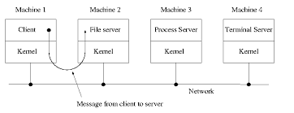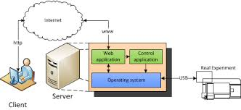

## 🔹 What is the Client–Server Model in OS?

The **client–server model** in operating systems is an architecture where the **OS services** (like file system, memory, device management, networking, etc.) are implemented as **server processes**, and applications (clients) request services from them.

* The **client** = requester of a service
* The **server** = provider of the service
* Communication happens via **message passing** or **Inter-Process Communication (IPC)**

This model is mostly used in **microkernel-based OS**.

## 🔹 Structure

1. **User Applications (Clients)**
   * Programs that need OS services (e.g., text editor, browser).
2. **Client-Side Stub**
   * Converts the client’s request into a message and sends it to the server.
3. **Servers (User-Space Services)**
   * Separate processes for each OS service (file server, print server, memory manager, etc.).
4. **Microkernel**
   * Provides minimal support like IPC, scheduling, and communication between clients and servers.
5. **Hardware**
   * Physical layer (CPU, memory, devices).

## 🔹 How it Works (Step by Step)

1. Client (application) sends a request for a service (e.g., open a file).
2. The request is packaged and sent to the **appropriate server process** via IPC.
3. The server performs the operation (e.g., reads file data).
4. The server sends the result back to the client.

## 🔹 Advantages

✅ **Modularity** – services are independent processes.  
✅ **Fault Isolation** – if a server crashes (e.g., printer server), others keep working.  
✅ **Security** – controlled communication between clients and servers.  
✅ **Distributed Systems Support** – can extend across a network (clients on one machine, servers on another).

## 🔹 Disadvantages

❌ **Performance Overhead** – message passing is slower than direct procedure calls.  
❌ **Complexity** – requires efficient IPC mechanisms.  
❌ **Latency** – each request/response cycle adds delay.

## 🔹 Examples

* **Mach (microkernel)** – OS services like file system run as servers.
* **MINIX 3** – file server, process server, and driver server run separately.
* **QNX** – heavily client–server based, widely used in embedded systems.

👉 **In short:**  
The **Client–Server OS model** = applications (clients) request services from independent OS servers via IPC, usually built on top of a microkernel.

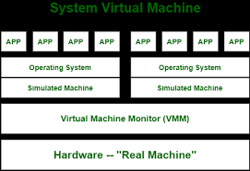

## 🔹 What is a Virtual Machine?

A **virtual machine (VM)** is an abstraction where the operating system (or a special software called a **virtual machine monitor** / **hypervisor**) creates the illusion that each user (or process) has an **independent machine** with its own hardware and OS.

👉 In simple words:

* VM = “software-based computer” running on top of real hardware.
* Multiple VMs can run **simultaneously** on the same physical machine.

## 🔹 Structure of Virtual Machine OS

The structure typically looks like this:

1. **Hardware**
   * Physical CPU, memory, disk, I/O devices.
2. **Virtual Machine Monitor (VMM) / Hypervisor**
   * Sits directly on the hardware.
   * Provides an interface that looks like the real hardware.
   * Divides physical resources among multiple virtual machines.
3. **Virtual Machines (Guest OS)**
   * Each VM runs its own **operating system** (guest OS) and applications.
   * They believe they have the entire hardware to themselves.
4. **Applications**
   * Run inside each guest OS just like they would on a real machine.

## 🔹 Two Types of VMM / Hypervisors

1. **Type 1 (Bare-Metal Hypervisor)**
   * Runs directly on hardware.
   * Examples: VMware ESXi, Microsoft Hyper-V, Xen.
2. **Type 2 (Hosted Hypervisor)**
   * Runs on top of a host OS.
   * Examples: VirtualBox, VMware Workstation.

## 🔹 Advantages

✅ **Isolation** – Each VM is isolated; crash of one doesn’t affect others.  
✅ **Security** – Malware in one VM cannot easily escape to another.  
✅ **Resource Sharing** – Multiple OSs share the same hardware efficiently.  
✅ **Portability** – VMs can be moved (migrated) across machines.  
✅ **Testing & Development** – Can test different OSs without extra hardware.

## 🔹 Disadvantages

❌ **Performance Overhead** – Running multiple VMs slows down performance due to virtualization layer.  
❌ **Resource Intensive** – Needs more CPU, RAM, and disk space.  
❌ **Complexity** – Management of many VMs can be challenging.

## 🔹 Examples

* **VMware ESXi / Workstation**
* **VirtualBox**
* **KVM (Linux Kernel-based Virtual Machine)**
* **Microsoft Hyper-V**
* **Xen**

👉 **In short:**  
The **Virtual Machine Structure** = Hypervisor sits between hardware and guest OS, creating multiple independent “computers” on one machine.

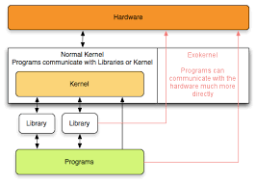

## 🔹 What is an Exokernel?

An **Exokernel** is an OS architecture designed to be **very small and simple**.

* Unlike a monolithic kernel (big) or microkernel (minimal but with services in user space), the exokernel’s job is only to **securely multiplex hardware resources** among applications.
* Instead of abstracting hardware, it **exposes raw hardware resources directly** to applications.
* Higher-level functions (file system, memory management, etc.) are implemented in **user-space libraries**, not in the kernel.

👉 Think of it as:  
**Exokernel = “thin layer” that only enforces protection and sharing, while leaving the actual management to user-level libraries.**

## 🔹 Structure of Exokernel OS

1. **Hardware**
   * CPU, memory, I/O devices.
2. **Exokernel**
   * Very thin kernel layer.
   * Functions: resource allocation, protection, multiplexing.
   * Does NOT provide abstractions like files, processes, or sockets.
3. **Library Operating Systems (LibOS)**
   * User-level libraries that implement traditional OS abstractions (file system, virtual memory, networking).
   * Each application can use its own LibOS, customized to its needs.
4. **Applications**
   * Run on top of their chosen LibOS.

## 🔹 How it Works

* Traditional OS: kernel gives you a file system (e.g., ext4, NTFS).
* Exokernel: kernel gives you only **disk blocks** → application can choose its own file system library.
* Traditional OS: kernel manages virtual memory.
* Exokernel: kernel only ensures memory protection → applications manage their own virtual memory via libraries.

## 🔹 Advantages

✅ **Flexibility** – Applications can define their own abstractions (e.g., custom file systems).  
✅ **Efficiency** – Direct hardware access reduces overhead.  
✅ **Performance** – Applications avoid unnecessary layers; “do only what you need.”  
✅ **Modularity** – Different applications can use different LibOS implementations.

## 🔹 Disadvantages

❌ **Complexity for Developers** – Applications must rely on LibOS or implement their own abstractions.  
❌ **Portability Issues** – Each LibOS may differ; less standardization.  
❌ **Security Risks** – Exposing hardware directly increases risk if not carefully controlled.  
❌ **Not Widely Adopted** – More of a research idea than mainstream OS design.

## 🔹 Examples

* **MIT Exokernel Project (1994–1997)** – first prototype.
* **Nemesis OS** – designed for multimedia applications.
* **ExOS** – an exokernel-based operating system from MIT.

👉 **In short:**  
An **Exokernel OS** is a **thin kernel** that only manages resource protection and sharing, leaving everything else to user-level libraries → giving apps maximum freedom and performance.

# 🔹 What is a Real-Time Operating System (RTOS)?

A **Real-Time Operating System** is an OS designed to **respond to inputs/events within a guaranteed time limit**.

* Focus: **Correctness = (Logical result + Time of response)**
* Used in **time-critical systems** where even a small delay can cause failure.
* Example: Airbag system in cars → must inflate **within milliseconds** during a crash.

# 🔹 Characteristics of RTOS

1. **Deterministic Response** → Predictable timing behavior.
2. **Low Latency** → Very fast context switching.
3. **Priority Scheduling** → Critical tasks get highest CPU priority.
4. **Reliability & Stability** → Must not fail under heavy load.
5. **Concurrency** → Handles multiple real-time tasks.

# 🔹 Types of RTOS

1. **Hard Real-Time OS**
   * Deadline **must always** be met.
   * Failure = system crash/fatal consequences.
   * Examples: Air traffic control, pacemakers, anti-lock braking systems.
2. **Soft Real-Time OS**
   * Deadline is important but **occasional misses are tolerable**.
   * Examples: Video streaming, online gaming, multimedia systems.

# 🔹 Examples of RTOS

* **QNX** (used in cars, medical devices)
* **VxWorks** (used in spacecraft, defense)
* **RTLinux** (Linux with real-time patches)
* **FreeRTOS** (popular in embedded systems, IoT)

# 🔹 Advantages

✅ Predictable & reliable performance  
✅ Fast response to critical events  
✅ Priority-based task scheduling  
✅ Suitable for safety-critical systems

# 🔹 Disadvantages

❌ More expensive than general-purpose OS  
❌ Limited multitasking (focus on deadlines, not throughput)  
❌ Complex to design and program

# 🔹 Real-Life Applications

* **Automotive**: Airbags, anti-lock brakes, engine control
* **Aerospace**: Flight control, satellite systems
* **Medical**: Heart monitors, infusion pumps
* **Industrial**: Robotics, process control
* **Telecom**: Network routers, base stations